**CSE 5331 – project 2 report**

**Team Members:**

Saahil Pralhad Anande(1001855308)

Unnathi Reddy Nalla (1001828087)

**Programing language:** Python

**Database:** Mysql, mongodb

**Libraries**: json, mysql.connector, pymongo, dicttoxml, ast

**Code structure: Option 1:** Load the data in a relational DBMS such as MySQL

1. To implement this project we first create 4 table in MYSQL. Employee, department, project, workson.
2. After creating the table run the python file name data_to_mysql which would read different text file and upload its data to mysql
3. When the data is uploaded to mysql run the python file convert_to_json_and_mongo_import which would extract the data from mysql database and perform some query to upload the nested document to json and mongodb.
4. Connect to mongodb in locahost and perform queries

**Loaded data in Mysql:**

We have created tables for each given input text files and loaded data into respective tables in Mysql.

* **Employee Table:**

Create Table using the following query-

CREATE TABLE employee (

emp_first varchar(255),

emp_last varchar(255),

emp_ssn int,

emp_birth varchar(255),

emp_address varchar(255),

emp_gender varchar(50),

emp_salary int,

mnger_ssn varchar(50),

emp_depno int,

PRIMARY KEY (emp_ssn)

);

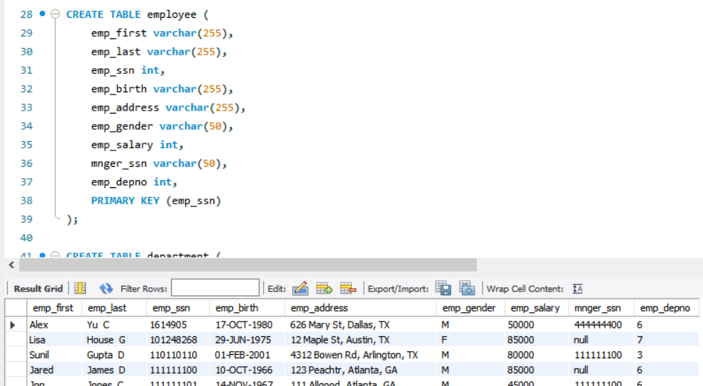

The table is late loaded using data_to_mysql python program.

* **Department table:**

Created table department in Mysql with the following query:

CREATE TABLE department (

d_name varchar(255),

d_no int,

mng_ssn int,

mng_start_date varchar(50),

primary key (d_no)

);

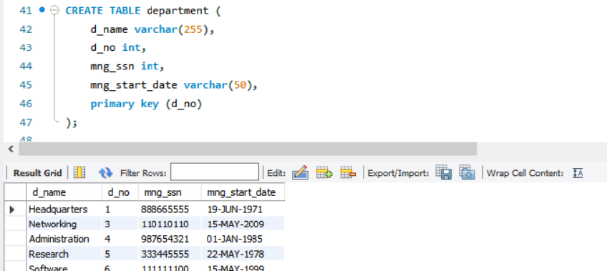

The table is late loaded using data_to_mysql python program.

* **Project table:**

Created table project in Mysql with the following query:

CREATE TABLE project (

p_name varchar(255),

p_no int,

p_location varchar(50),

d_num int,

primary key (p_no)

);

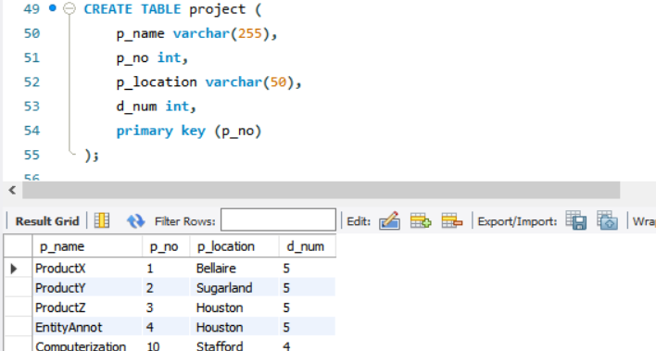

* **Works on table:**

Created table workson in Mysql with the following query:

CREATE TABLE workson

(essn int,

pno int,

hours int,

primary key (essn,pno)

);

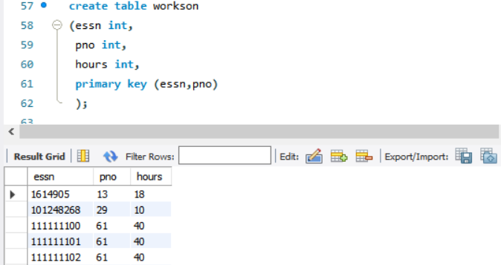

The table is late loaded using data_to_mysql python program.

**Pseudo code:**

1. **Create tables employee, department, project, workson**.

**#extract and load the mysql table**

emplist = []

with open(FILENAME.txt', 'r') as file: # reading the input file  
 for line in file.readlines():

emplist = line.split(",")

#get row values for each table

**#Connect to mysql**

myConn = pymysql.connect(host=hostname, user=username, passwd=password, db=database )

#write and execute query to insert data in tables.

cursor = newconnection.cursor()  
query = "INSERT INTO employee (emp_first,emp_last , emp_ssn, emp_birth, emp_address,emp_gender,emp_salary,mnger_ssn,emp_depno) VALUES ('"+firstname+"','"+lastname+" "+middlename+"','"+emp_ssn+"','"+dateofbirth+"','"+address+", "+city+", "+state+"','"+gender+"','"+salary+"','"+mng_ssn+"','"+depno+"'); "  
cursor.execute(query)  
newconnection.commit()

**#use alter table and set foreign keys**

alter table department add foreign key (mng_ssn) references employee(emp_ssn);

alter table project add foreign key (d_num) references department(d_no);

alter table workson add foreign key (essn) references employee(emp_ssn), add foreign key (pno) references project(p_no);

1. **Once the table has been loaded write queries to join multiple tables.**

mycursor = newconnection.cursor()

query1 = "select p_no,p_name,d_num,emp_first,emp_last,hours from project p join department d on p.d_num = d.d_no join workson w on w.pno=p.p_no join employee e on e.emp_ssn = w.essn order by p.p_no"

mycursor.execute(query1)

myresult = mycursor.fetchall()

query2 = "select e.emp_ssn,e.emp_first,e.emp_last,d.d_name,p.p_name,p.p_no,w.hours from employee e join workson w on e.emp_ssn=w.essn join project p on p.p_no = w.pno join department d on d.d_no = e.emp_depno order by e.emp_ssn"

mycursor.execute(query)

employee_col_result = mycursor.fetchall()

query3 = "select d.d_no, d.d_name, e.emp_last, d.mng_start_date,e.emp_last, e.emp_first, e.emp_salary from department d join employee e on d.d_no =e.emp_depno order by d.d_no;"

mycursor.execute(query)

department_col_result = mycursor.fetchall()

1. Create a dictionaries for project document ‘project_document_collection’ for P_no, P_name, D_no and collection of employees emp_first, emp_last and hours
2. Create a dictionaries for employee document ‘employee_document_collection’ for emp_first, emp_last, D_no and collection of projects P_no, P_name and Hours.
3. Create a dictionaries for department document ‘department_document_collection’ for d_name, manger_last, manger_start and collection for employees emp_first, emp_last, salary.
4. Iterate the fetched data and append the result into the respective dictionaries. For the project document, if the p_no already exists in the dictionary then we only append the employee collection details else we will append all the project details as well as the employee collection details. For the employee document, if the emp_ssn already exists in the dictionary then we only append the project collection details else we will append all the employee details as well as the project collection details.

**#for creating project document collection**

jsonresult = {}  
for p_no, p_name,d_num,emp_first, emp_last, hours in myresult:  
 if p_no in jsonresult:  
 emp = {  
 "Employee_first_name" : emp_first,  
 "Employee_last_name" : emp_last,  
 "hours" : hours  
 }  
 jsonresult[p_no]["employee"].append(emp)  
 else:  
 jsonresult[p_no] = {  
 "Project_name" : p_name,  
 "project_number" : p_no,  
 "department_number" : d_num,  
 "employee" : [{  
 "Employee_first_name" : emp_first,  
 "Employee_last_name" : emp_last,  
 "hours" : hours  
 }]  
 }

**#for creating employee document collection**

jsonresult = {}  
for emp_ssn, emp_first, emp_last,d_name,p_name, p_no, hours in employee_col_result:  
 if emp_ssn in jsonresult:  
 pro = {  
 "project_name" : p_name,  
 "project_number" : p_no,  
 "Hours" : hours  
 }  
 jsonresult[emp_ssn]["project"].append(pro)  
 else:  
 jsonresult[emp_ssn] = {  
 "Employee_first_name" : emp_first,  
 "Employee_last_name" : emp_last,  
 "department_name" : d_name,  
 "project" : [{  
 "project_name" : p_name,  
 "project_number" : p_no,  
 "Hours" : hours  
 }]  
 }

**#for creating department document collection**

jsonresult = {}

for d_no, d_name, emp_last,mng_start_date,emp_last, emp_first, emp_salary in employee_col_result:

if d_no in jsonresult:

empy = {

"Employee_first_name" : emp_first,

"Employee_last_name" : emp_last,

"Salary" : hours

}

jsonresult[d_no]["employee"].append(pro)

else:

jsonresult[d_no] = {

"Department_name" : d_name,

"Manager_lastname" : emp_last,

"Manager_start_date" : mng_start_date,

"employee" : [{

"Employee_first_name" : emp_first,

"Employee_last_name" : emp_last,

"Salary" : hours

}]

}

**#** **Convert the project_document_collection, employee_document_collection and department_document_collection to json using json_dumps. Open a file and write the generated json string into department.json, project.jason, employee.jason file**

jsonconv = json.dumps(jsonresult)

**#write to file project_document.jason**

file="project_document.json"

with open(file, 'w') as out:

out.write(jsonconv + '\n')

**#write to file employee_document.jason**  
file="employee_document.json"  
with open(file, 'w') as out:  
 out.write(jsonconv + '\n')

**#write to file department_document.jason**  
file="department_document.json"  
with open(file, 'w') as out:  
 out.write(jsonconv + '\n')

# **Convert the project_document_collection, employee_document_collection and department_document_collection to XML using DICT TO XML. Open a file and write the generated json string into department_xml.xml, project_XML.xml, employee_XML.xml file**

**#xml file converstion**  
convo = literal_eval(jsonfile)  
xmlfile = dicttoxml(convo)  
  
**#write to file employee_document.xml**  
with open("EMPLOYEE_XML.xml", 'w') as out:  
 out.write(str(xmlfile, 'utf-8'))

**#insert the converted Jason to mongodb**

for x in jsonresult:  
 myclient = pymongo.MongoClient(mongodb_host)  
 mydb = myclient[mongodb_dbname]  
 mycol = mydb["project_document"]  
 mycol.insert_one(jsonresult[x])

for x in jsonresult:  
 myclient = pymongo.MongoClient(mongodb_host)  
 mydb = myclient[mongodb_dbname]  
 mycol = mydb["employee_document"]  
 mycol.insert_one(jsonresult[x])

for x in jsonresult:  
 myclient = pymongo.MongoClient(mongodb_host)  
 mydb = myclient[mongodb_dbname]  
 mycol = mydb["department_document"]  
 mycol.insert_one(jsonresult[x])

**#now we get mongo collection uber db2databse named project_document, employee_document , department_document**

**#we perform queries on these collections**

**Mongodb collections:**

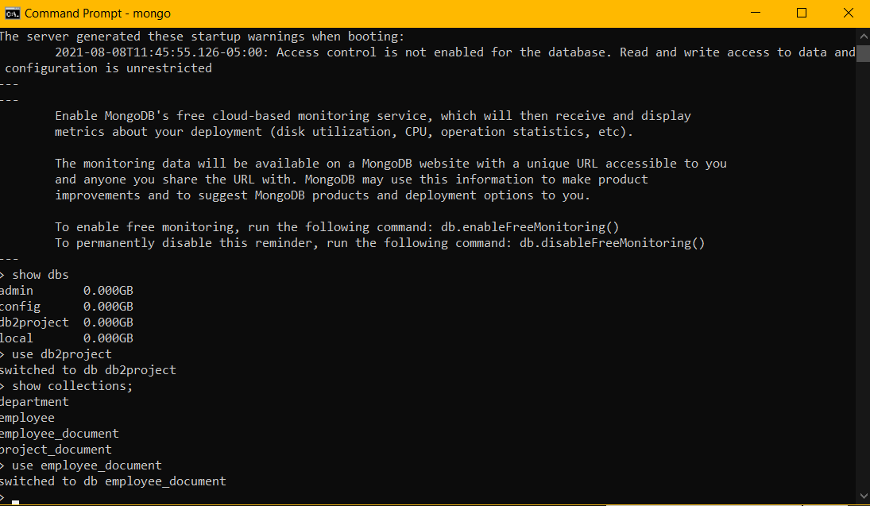

* Created project collection named ‘project_document’

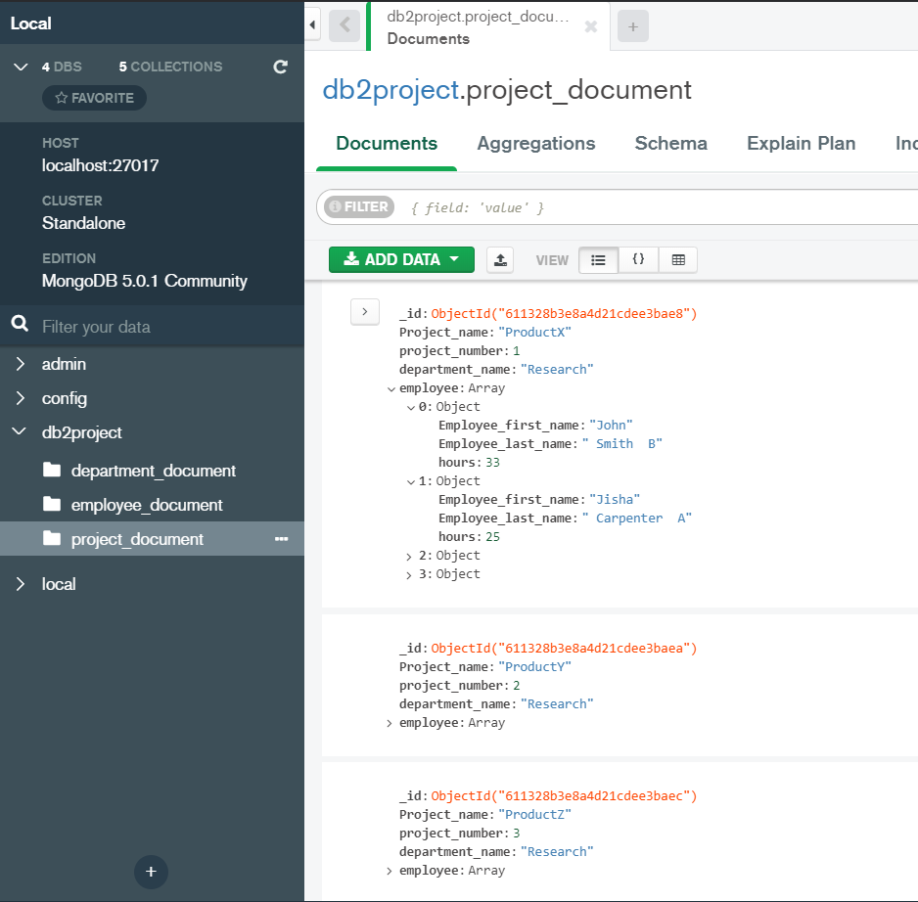

* Created employee collection named ‘employee_document’

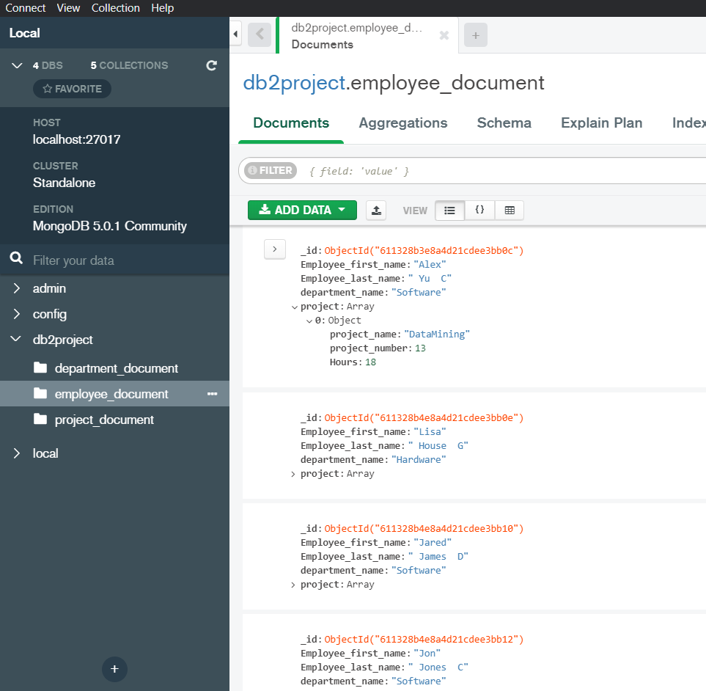

* Created collection named ‘department_document’

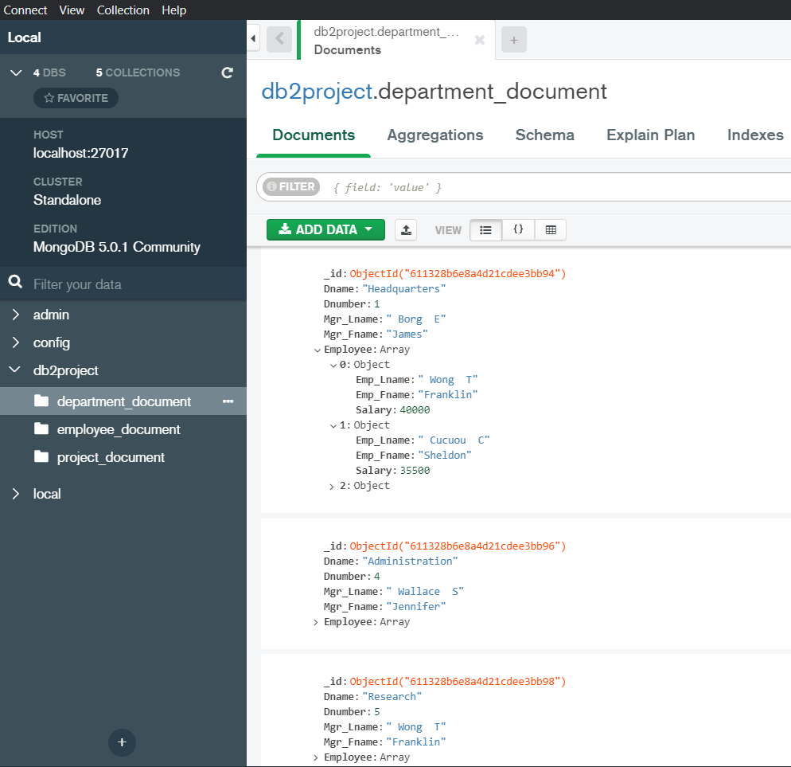

**Queries on project collection:**

1. Query whose project number is 11

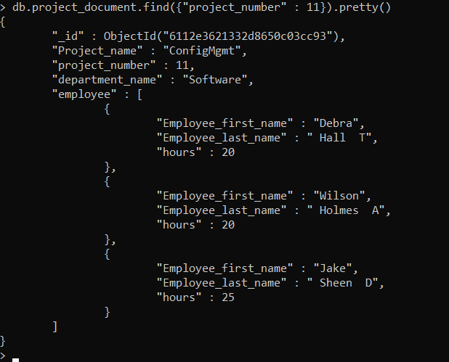

1. Query whose project number is 11 and employees in that department work greater than 20 hours.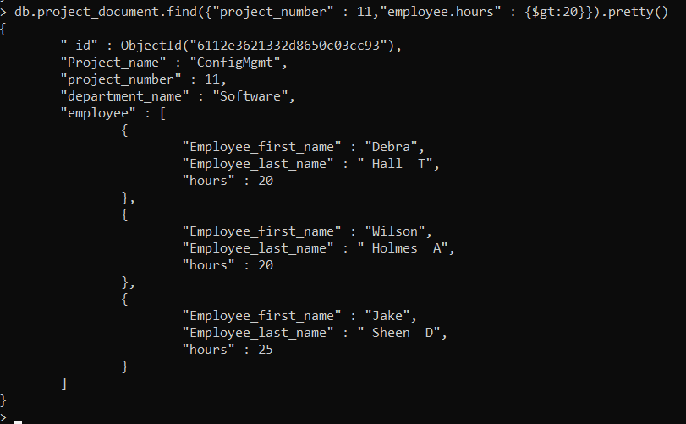
2. Query whose Employee name in the project collection is Debra.

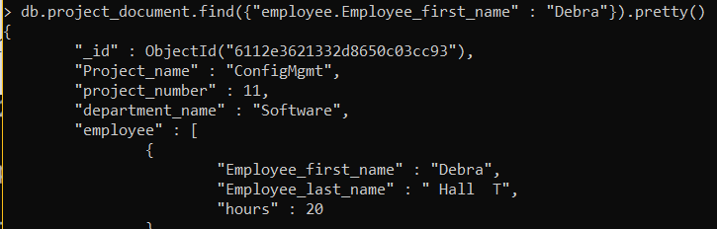

**Queries on Employee collection:**

1. Query whose First name is “Jake”.

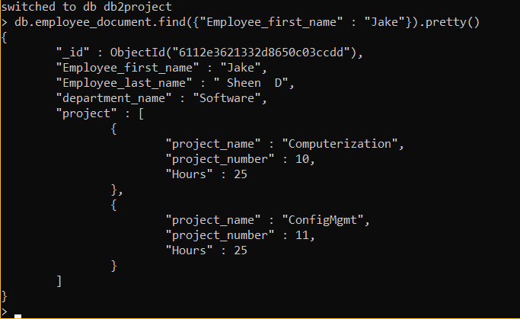

1. Query whose department name is “Software” and project number in that department is less than 12

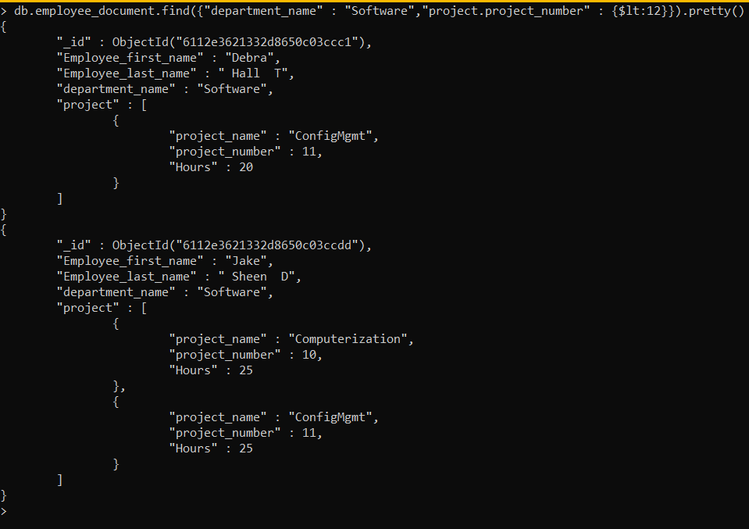

1. Query whose department name is software and employees in that department work greater than 40 hours.

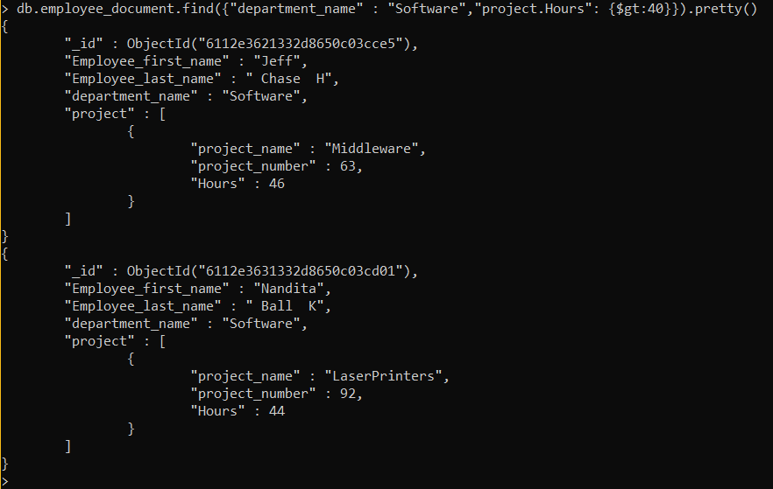

**Queries on Department collection:**

1. Query whose Manager last name is “Linda G”

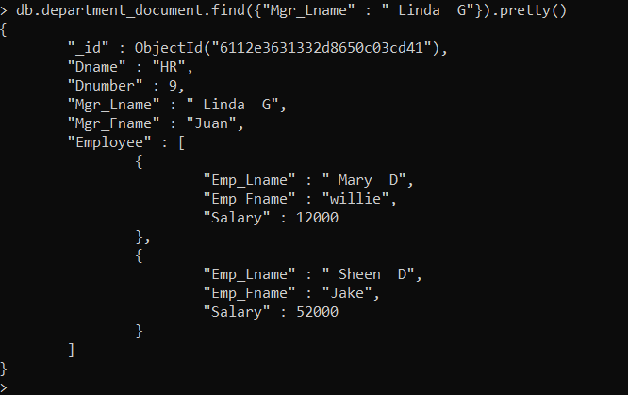

2. Query whose department name is “hardware” and employee salary is greater that 200000

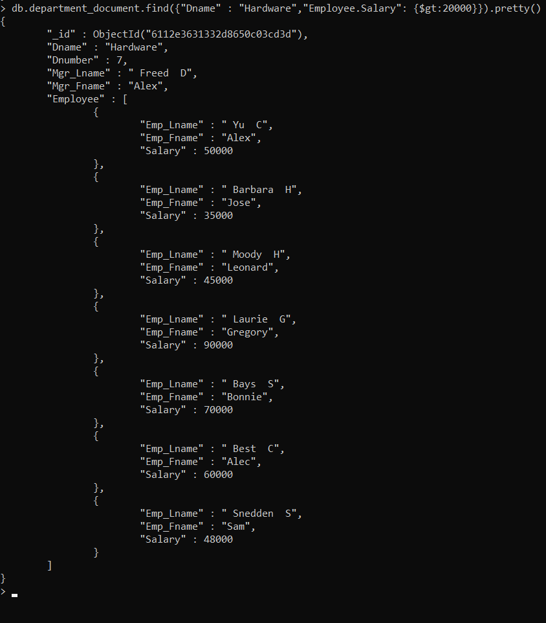

**Contribution by Each Team Member:**

Saahil anande worked on sql joins and mongo import

Unnathi reddy worked on nested Json and xml file structure and sql import.